Exp No:1 Configuration of Network Devices using Packet Tracer tools (Hub, Switch, Ethernet, Broadcast)

Output:

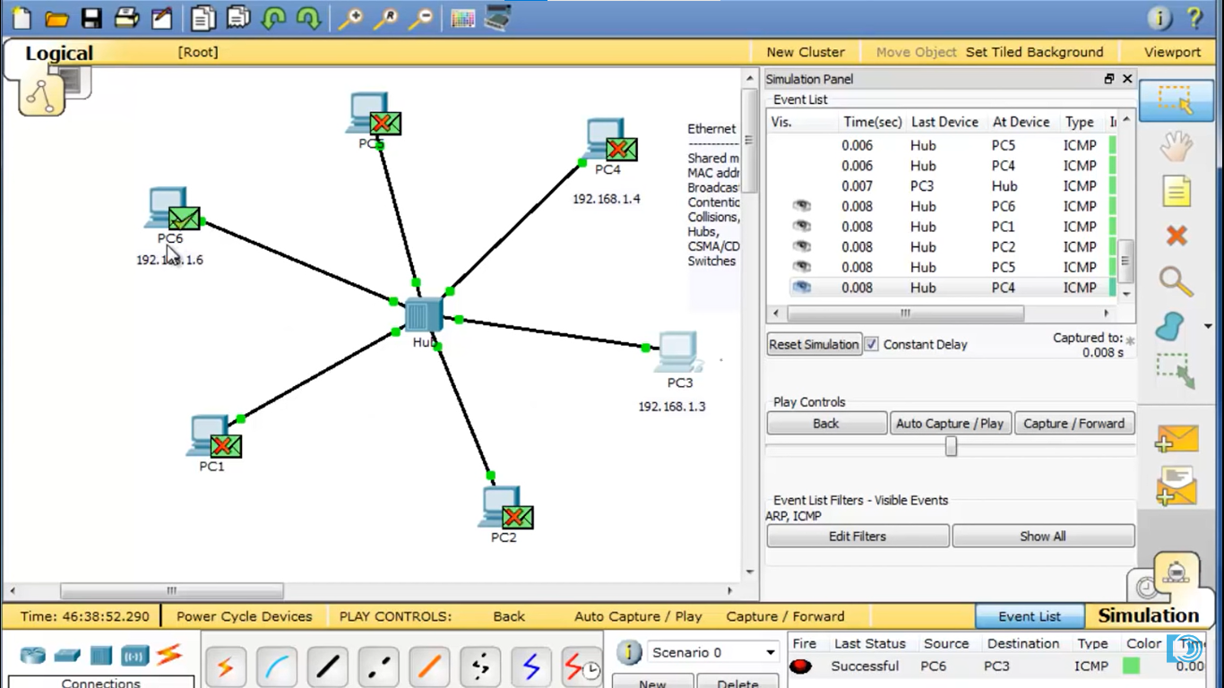

Exp No:2 Design and Configuration of Star Topologies using Packet Tracer.

Output**:**

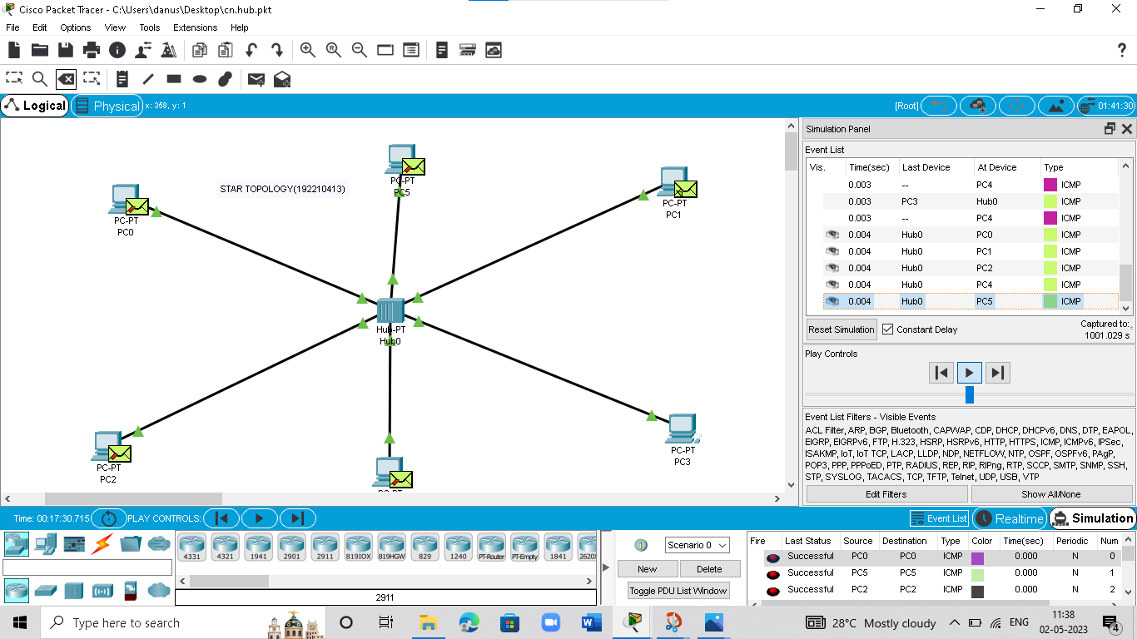

Exp No: 3 Design and Configuration of BUS Topologies using Packet Tracer.

**Output:**

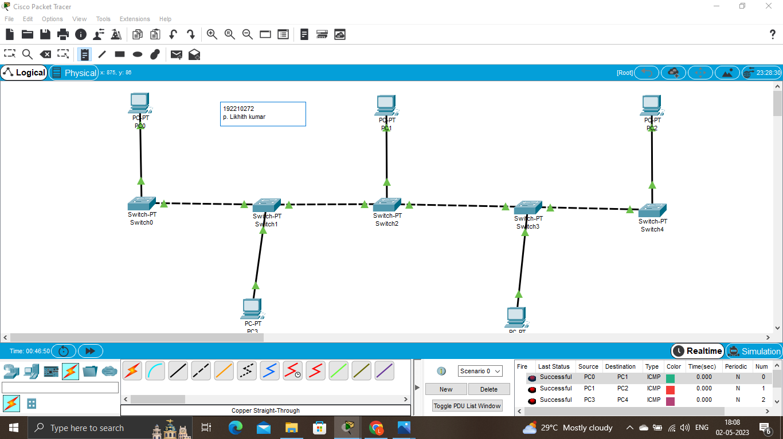

Exp No:4 Design and Configuration of RING Topologies using Packet Tracer

Output**:**

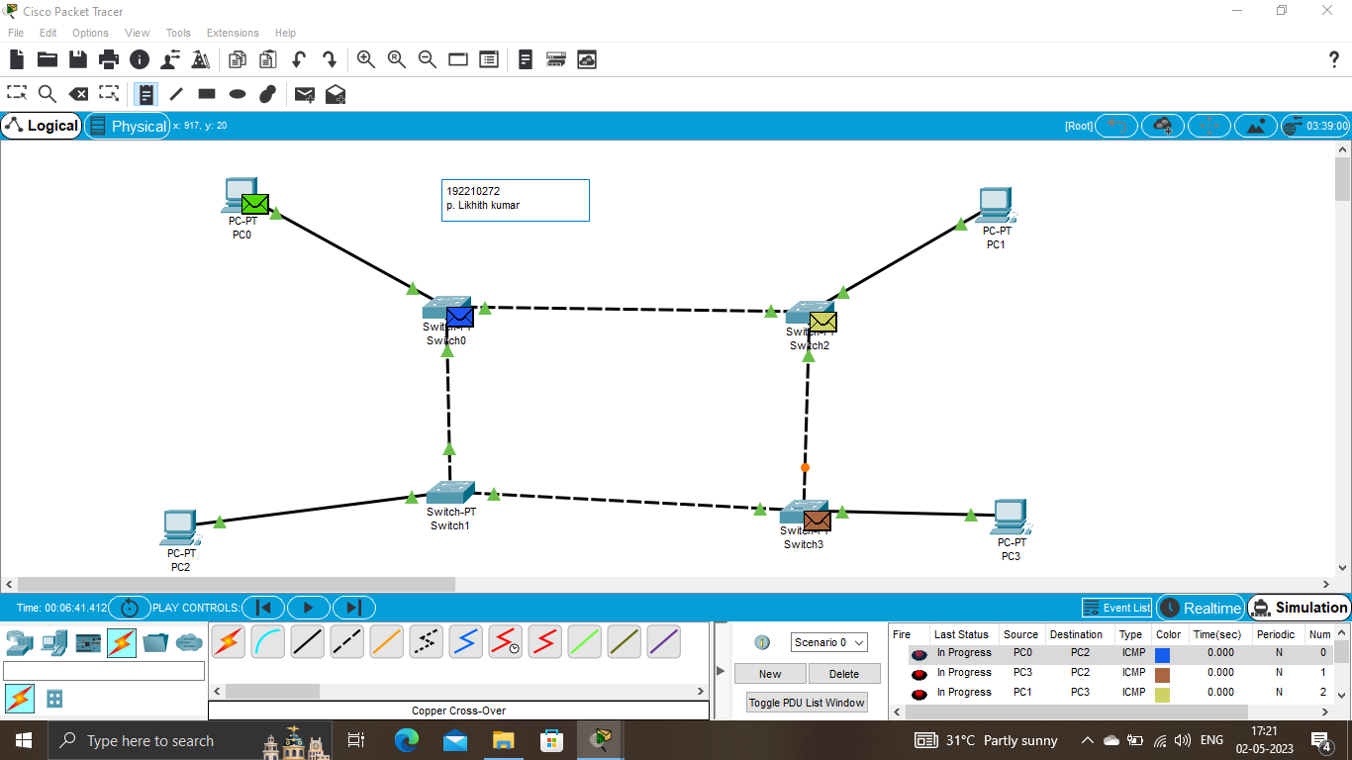

Exp No:5 Design and Configuration of Mesh Topologies using Packet Tracer

Output:

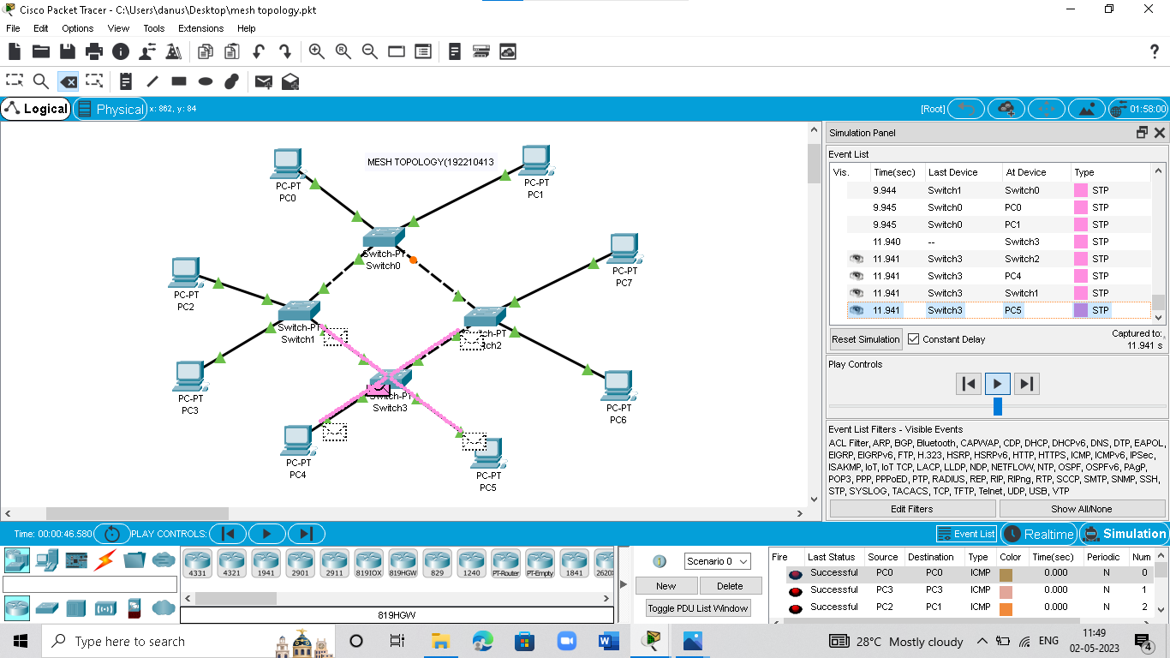

Exp No:6 Design and Configuration of Tree Topologies using Packet Tracer.

Output:

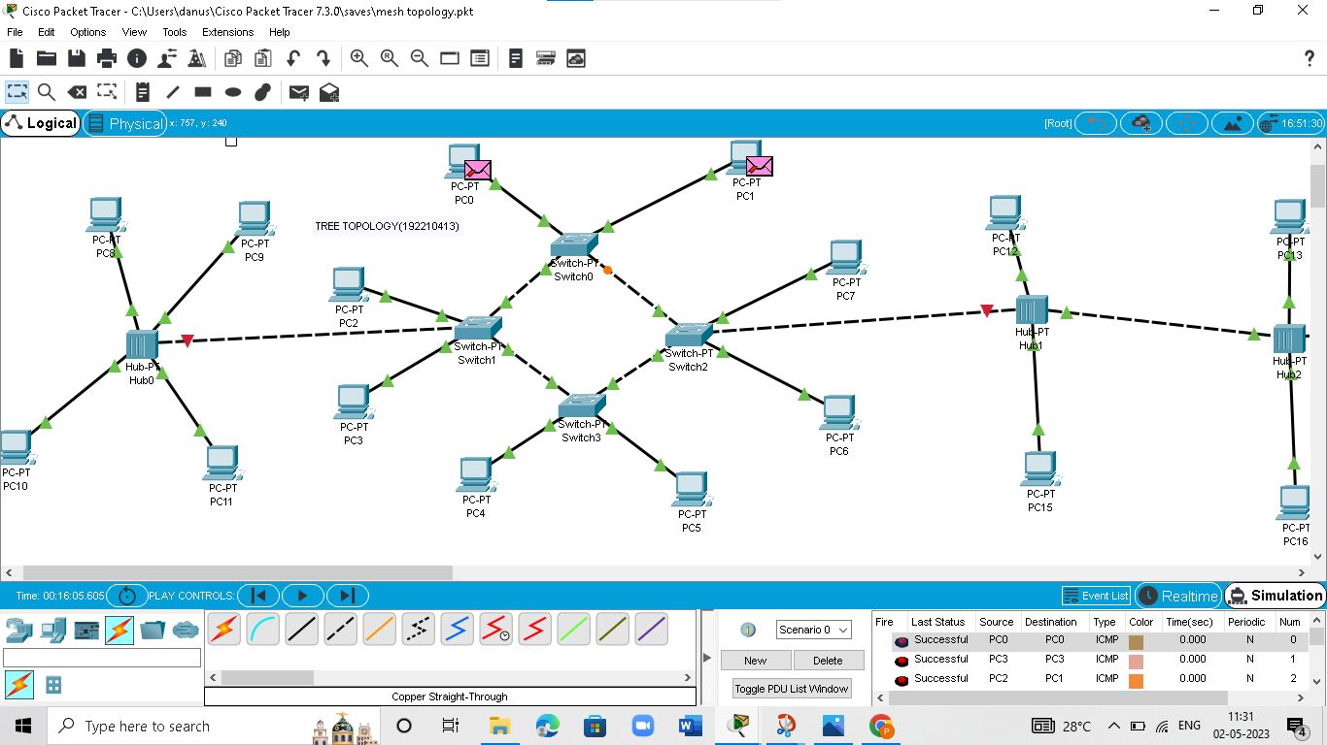

Exp No:7 Design and Configuration of Hybrid Topologies using Packet Tracer.

Output:

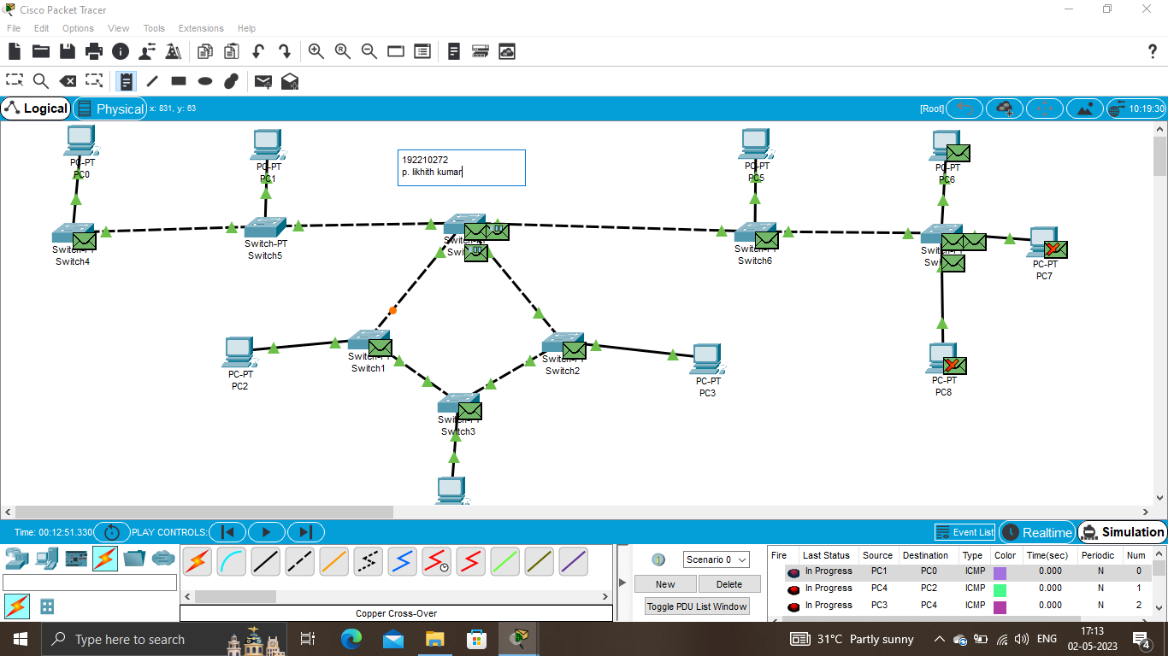

Exp No:8 Data Link Layer Traffic Simulation using Packet Tracer Analysis of ARP.

Output:

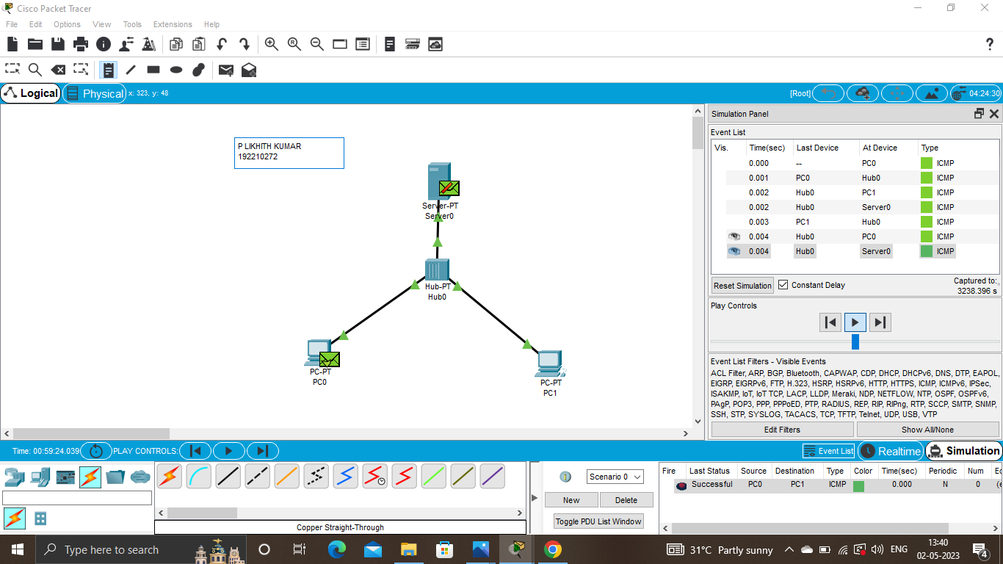

Exp No:9 Data Link Layer Traffic Simulation using Packet Tracer Analysis of CSMA/CD & CSMA/CA.

Output:

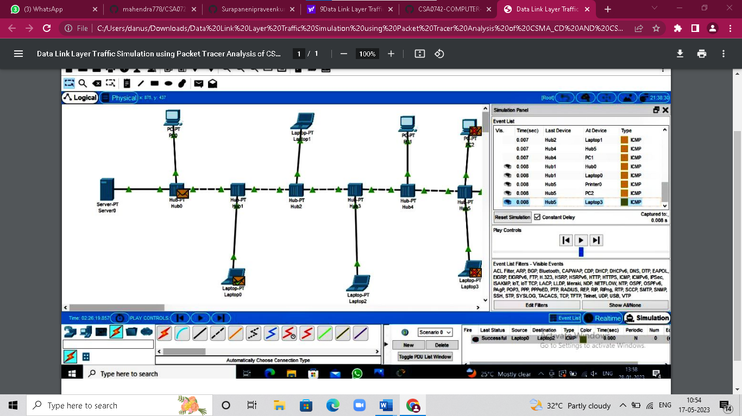

Exp No:10 Making Computer Lab in Cisco Packet Tracer

Output:

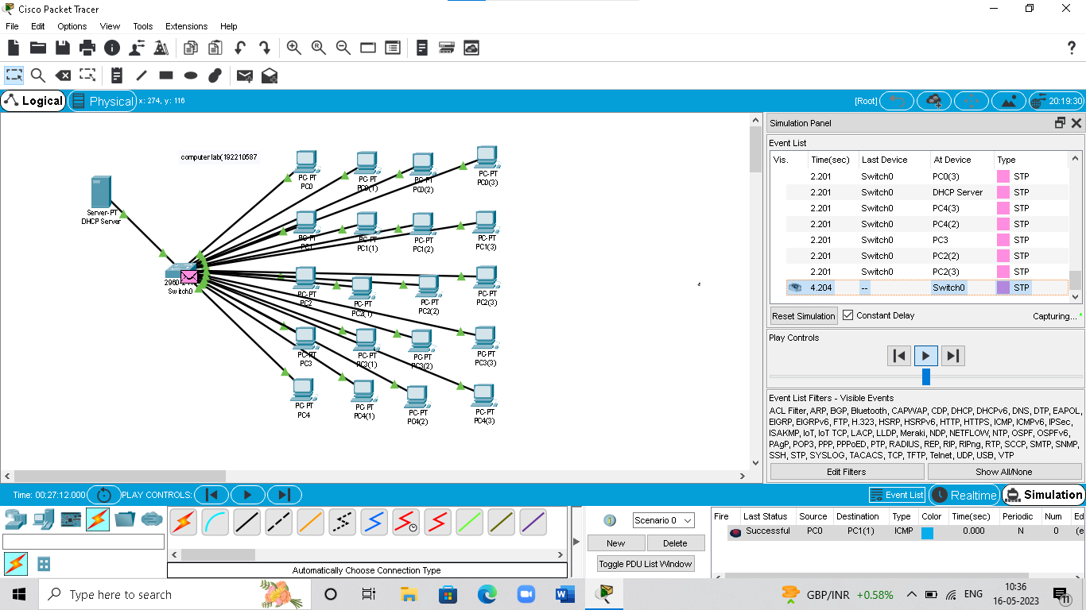

Exp No:11 Designing two different network with Static Routing techniques using Packet Tracer.

Output**:**

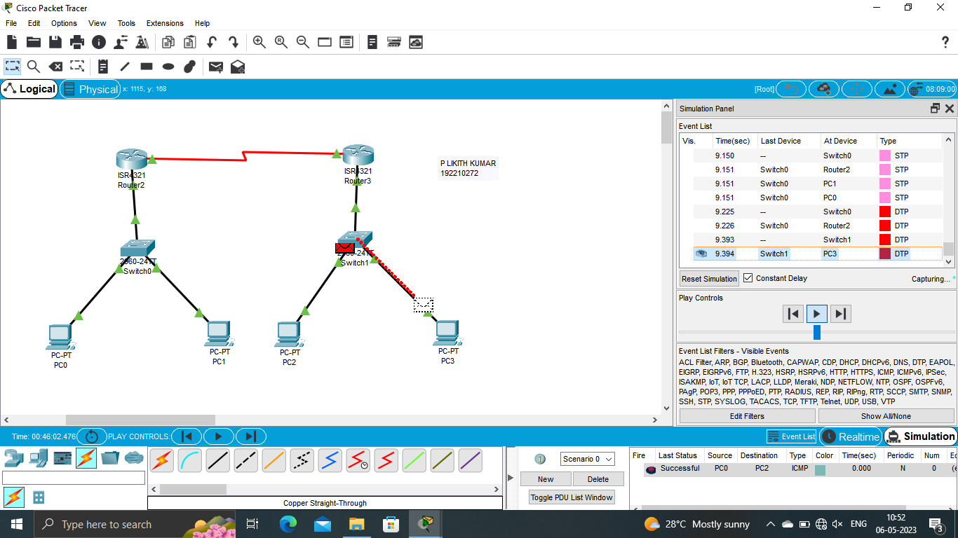

Exp No:12 Design the Functionalities and Exploration of TCP using Packet Tracer

Output**:**

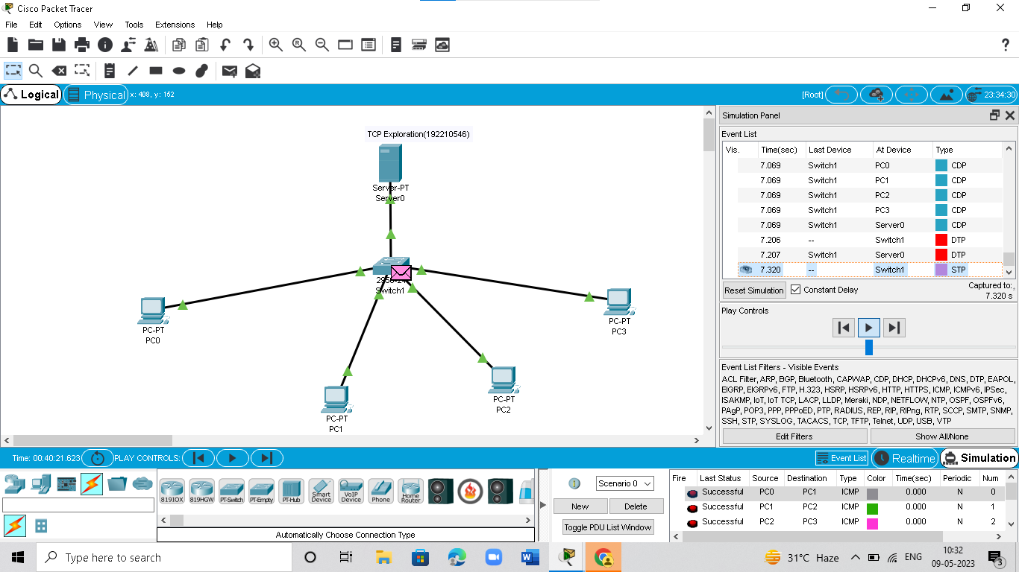

Exp No:13 Design the network model for Subnetting – Class C Addressing using Packet Tracer.

Output:

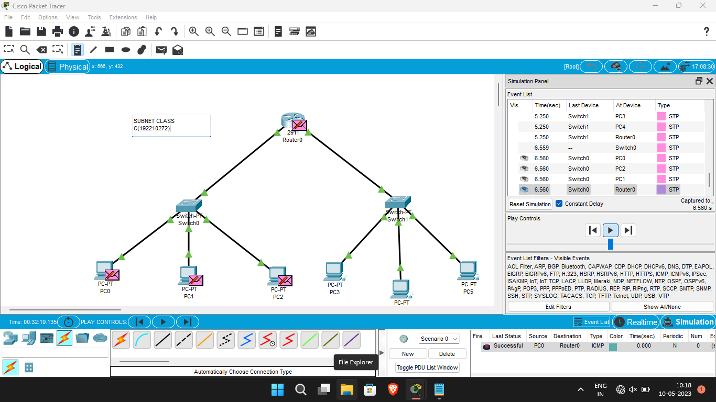

Exp No:14 Simulating X, Y, Z Company Network Design and simulate using Packet Tracer.

Output:

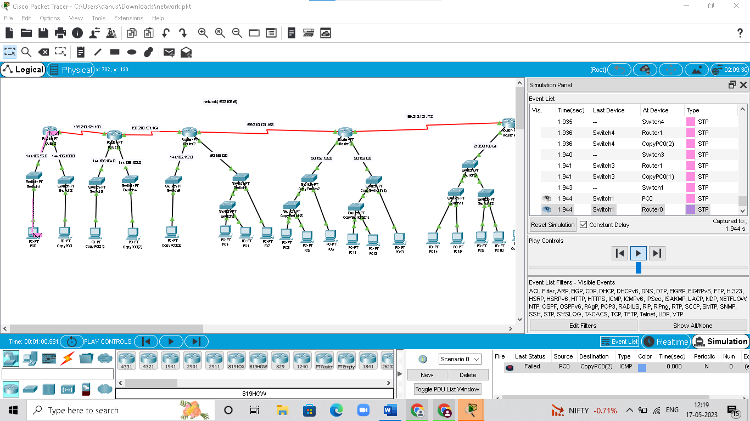

ExpNo:15 Configuration of DHCP (dynamic host configuration protocol) in packet Tracer.

Output:

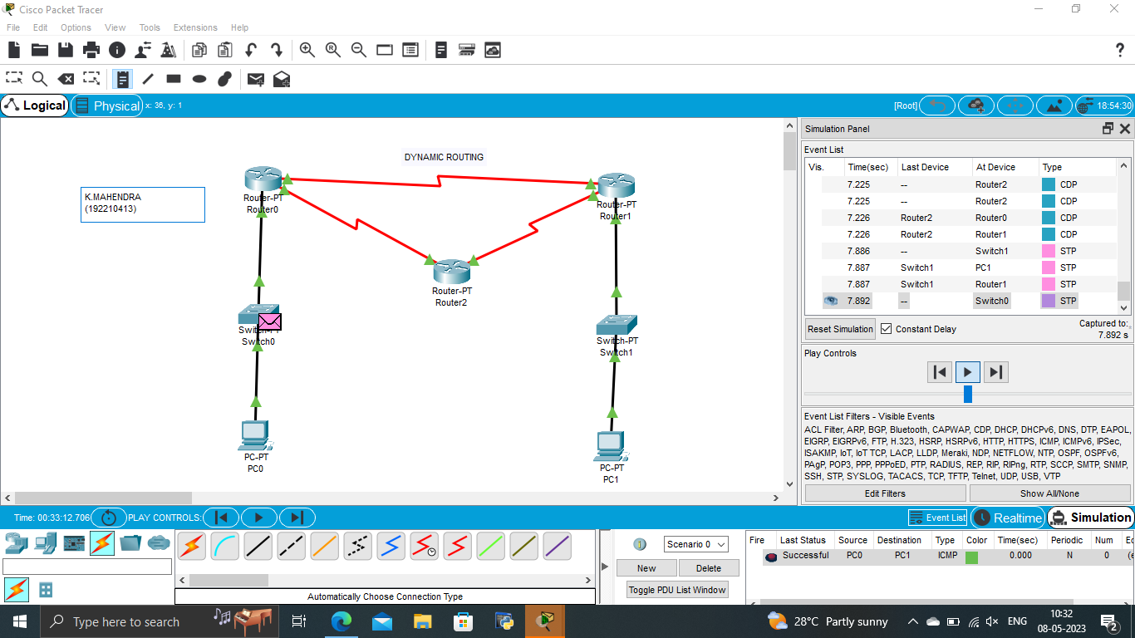

Exp No::16 Configuration of firewall in packet tracer.

Output**:**

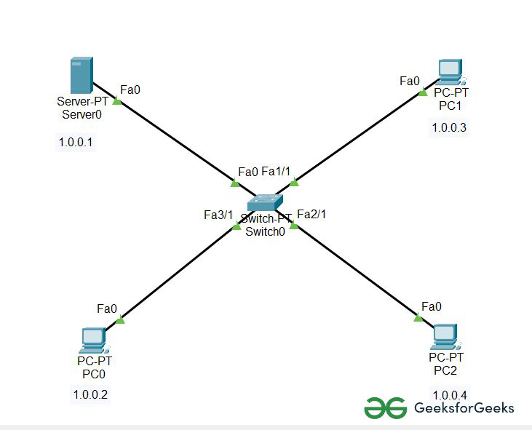

Exp No:17 Make a Computer Lab to transfer a message from one node to another to design and simulate using Cisco Packet Tracer.

Output**:**

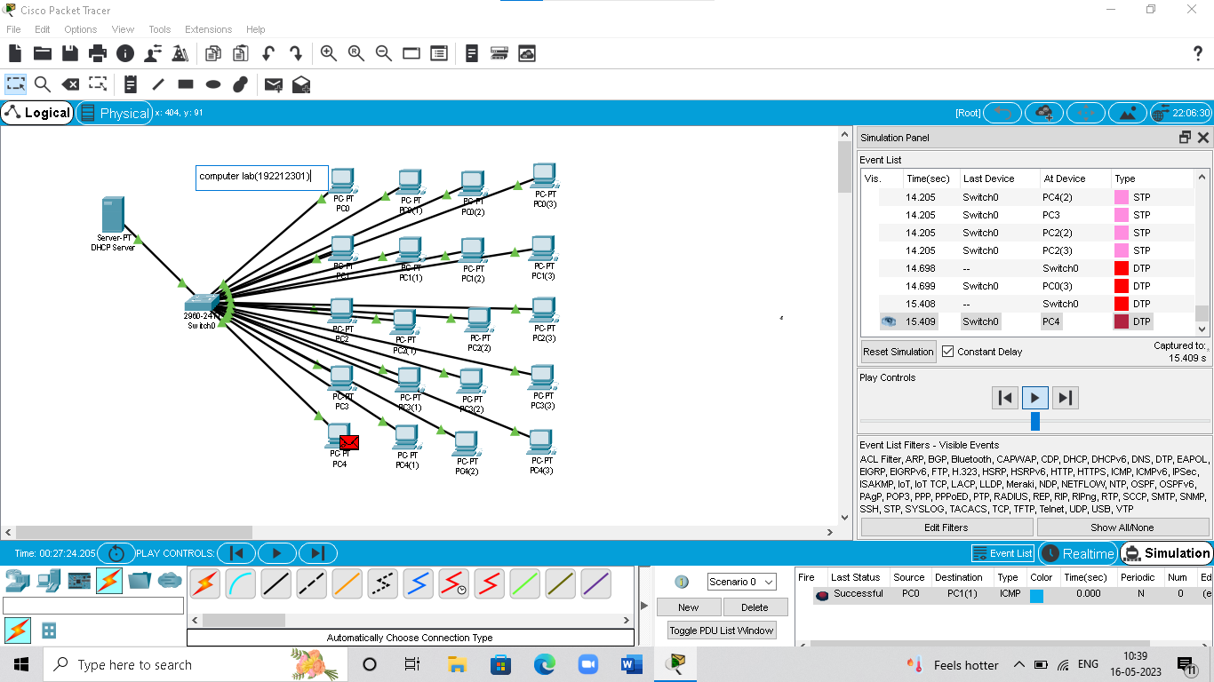

Exp No:18 Simulate a Multimedia Network in Cisco Packet Tracer.

Output:

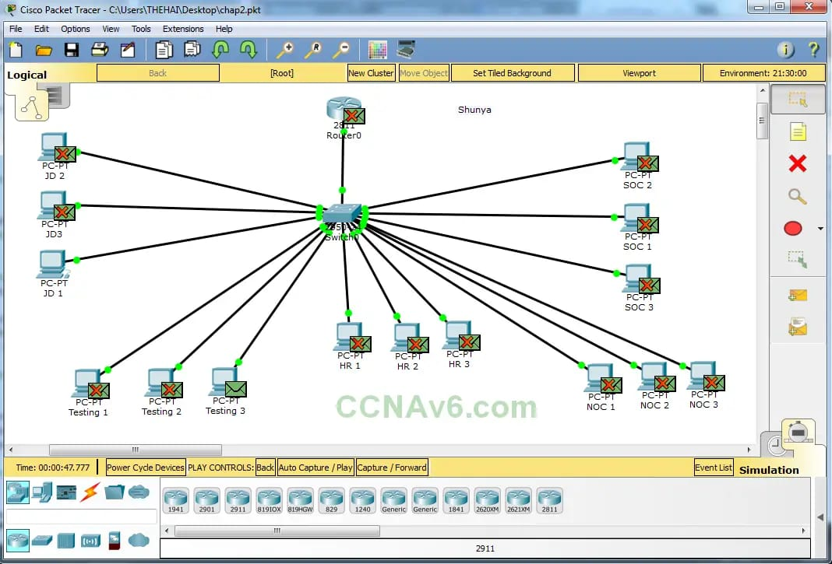

Exp No:19 IoT based smart home applications.

Output:

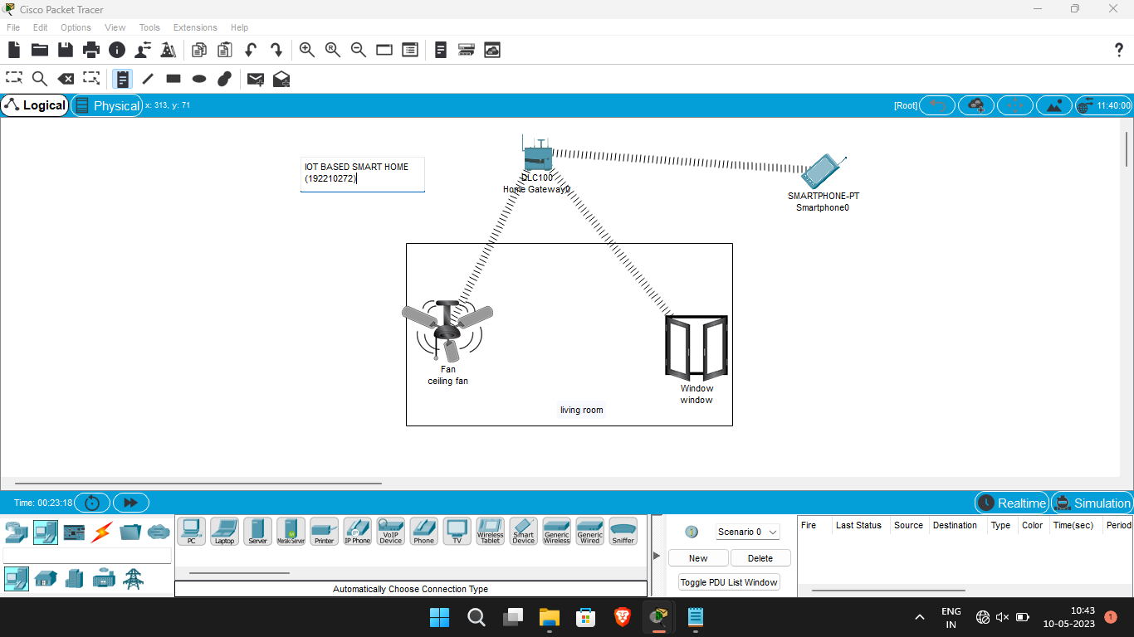

Exp No:20. Implementation of IoT based smart gardening.

Output:

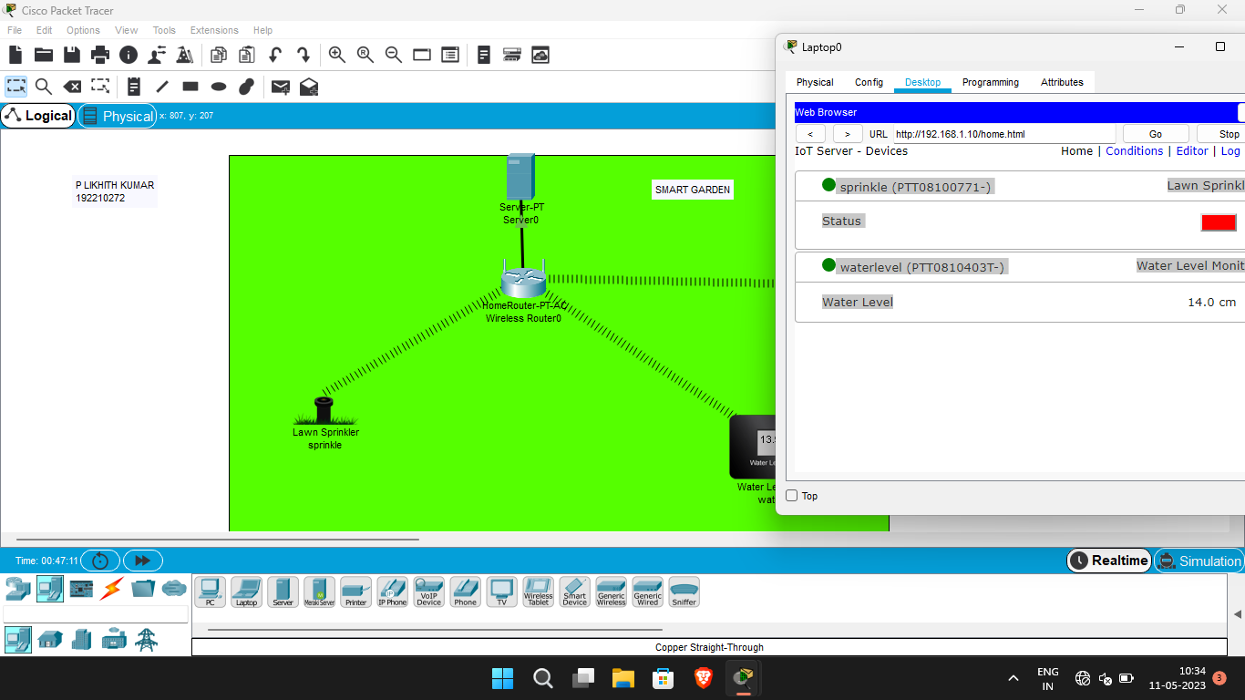

Exp No:21. Implementation of IoT devices in networking.

Output:

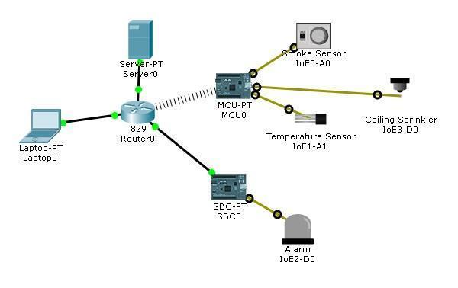

Exp No: 22. IoT based AAA Local and Server based authentication configuration.

Output:

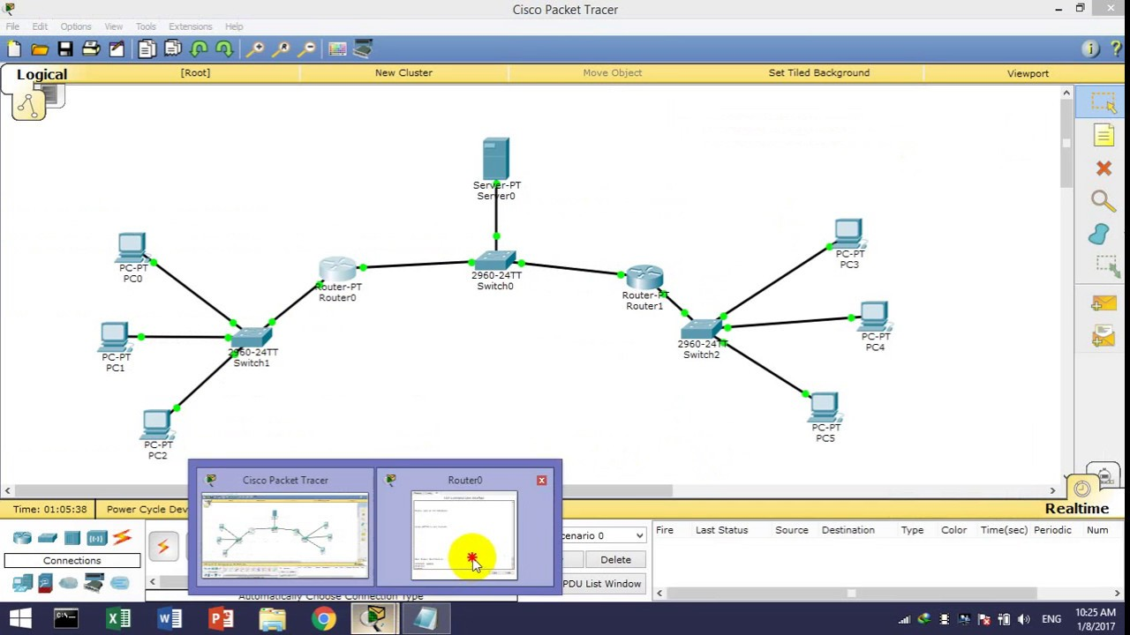

Exp :No 23. Transport layer protocol header analysis using Wire shark- TCP and UDP 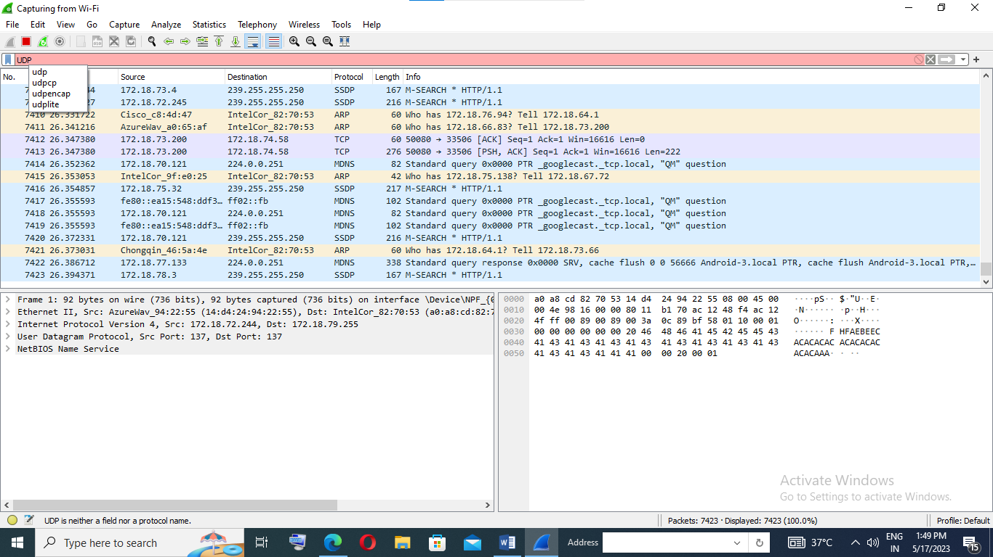

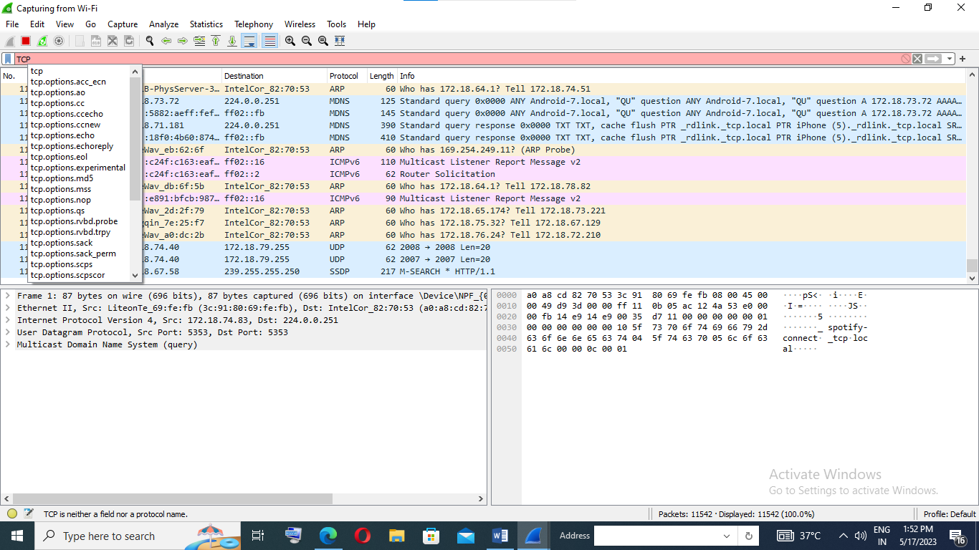

Exp No:24. Network layer protocol header analysis using Wire shark – SMTP and ICMP.

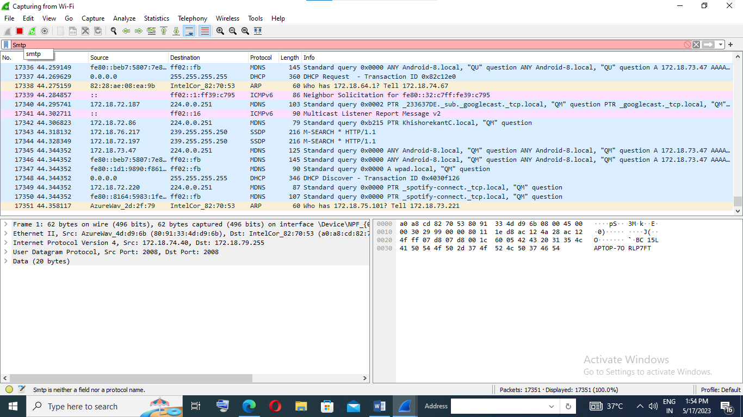

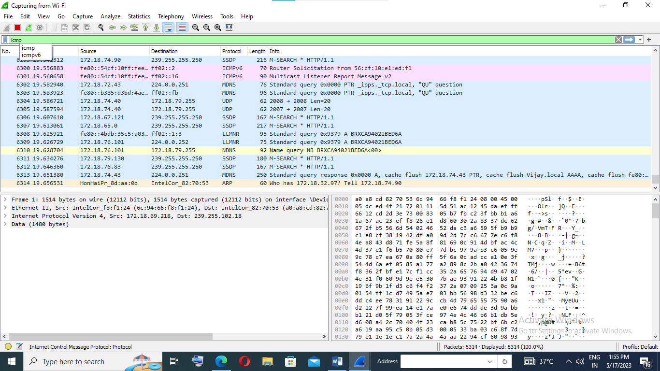

Exp No:25.Network layer protocol header analysis using Wire shark – ARP and HTTP.

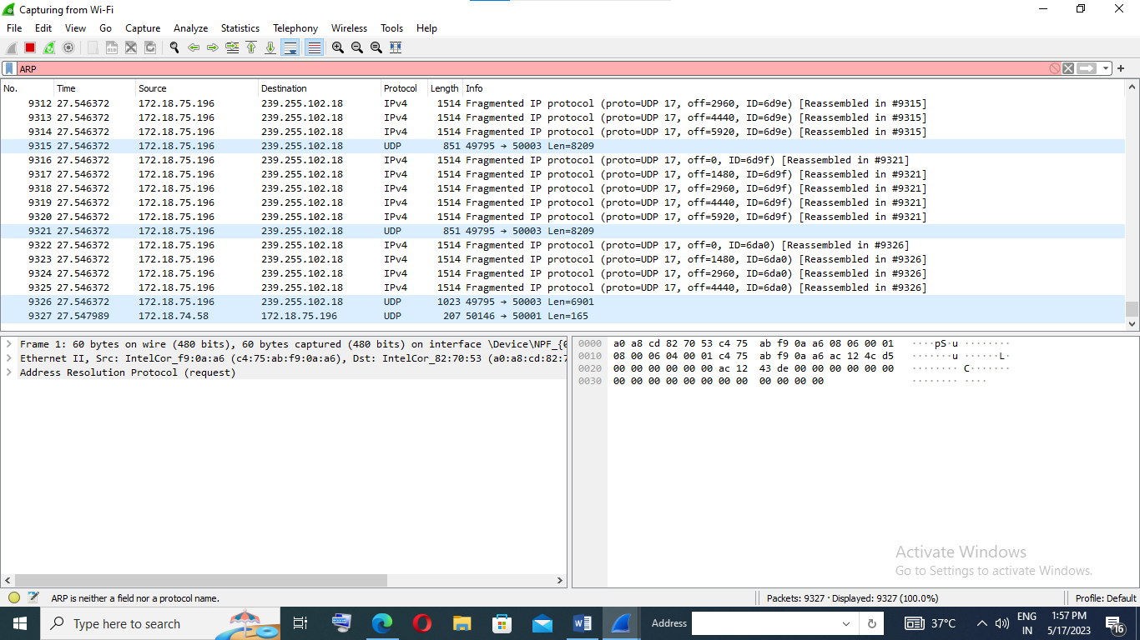

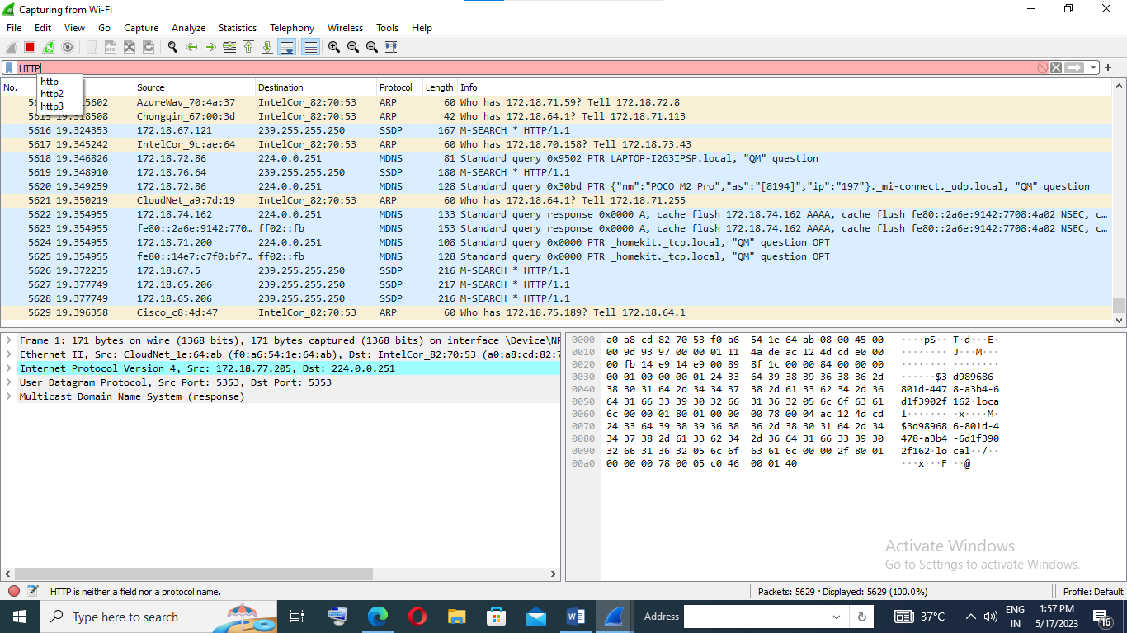

Exp No:26.Implementation of date and time display from client to server using TCP sockets in java/C.

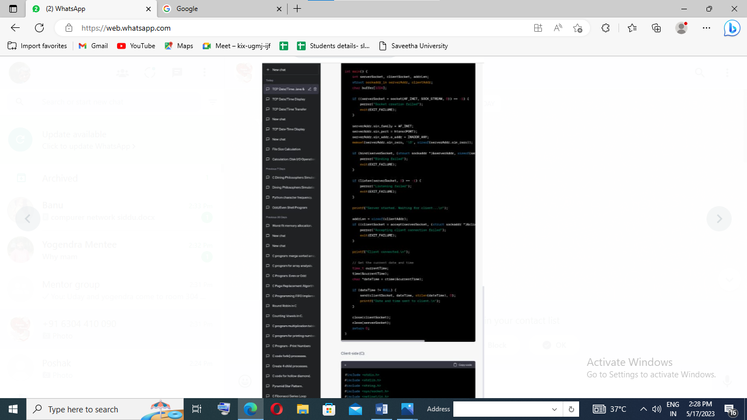

Exp No:27.Implementation of a DNS server and client in java/C using UDP sockets.

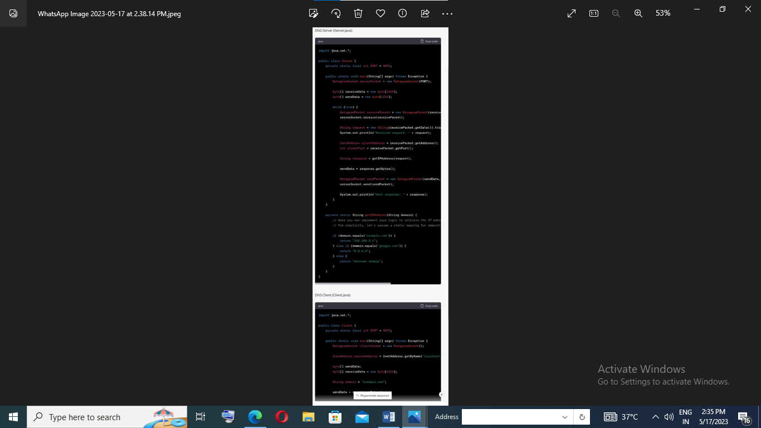

Exp No:28.Developing a client that contacts a given DNS server to resolve a given hostname in java.

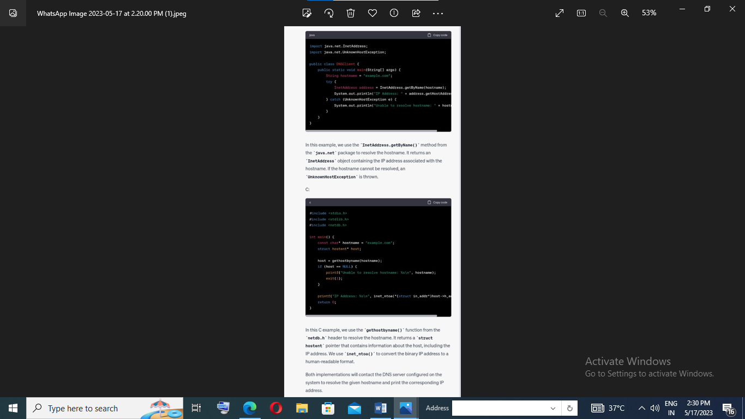

Exp No:29.Creating the applications using TCP echo server and client in java/C.

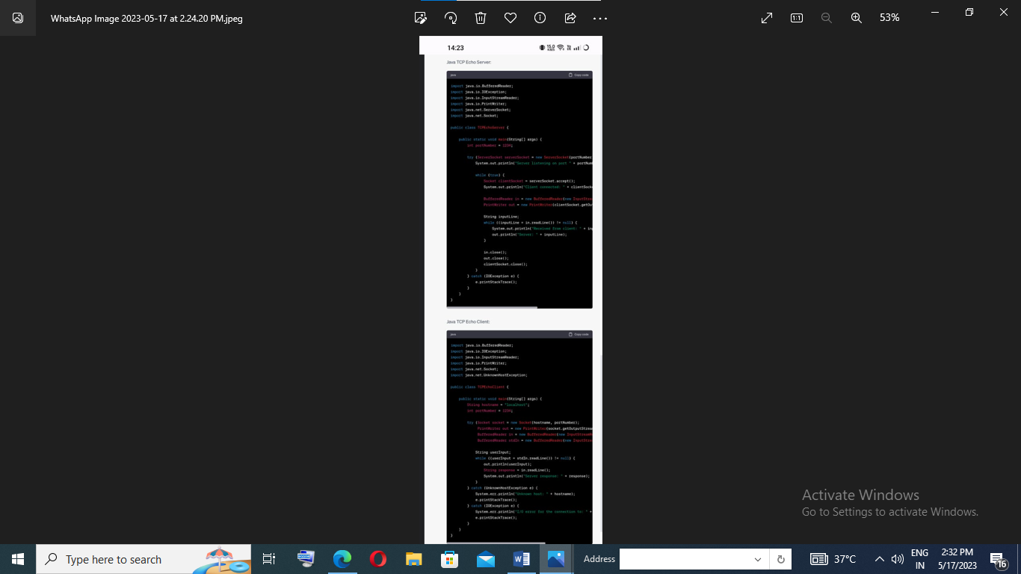

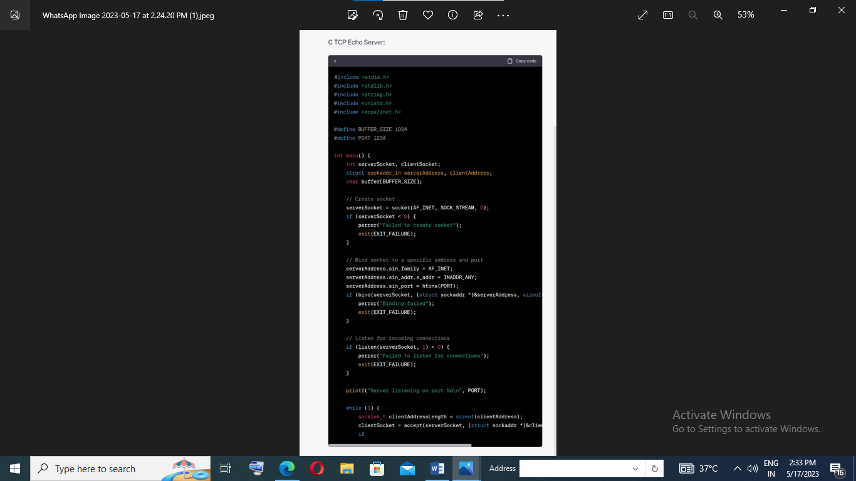

Exp No:30.Creating the applications using TCP chat client and chat server in java/C.

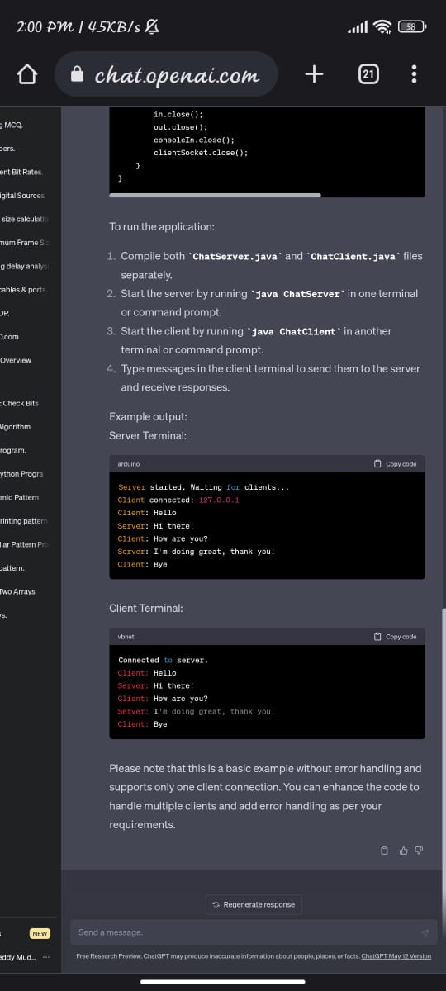

Exp No:31. Implementing ARP protocols in java/c

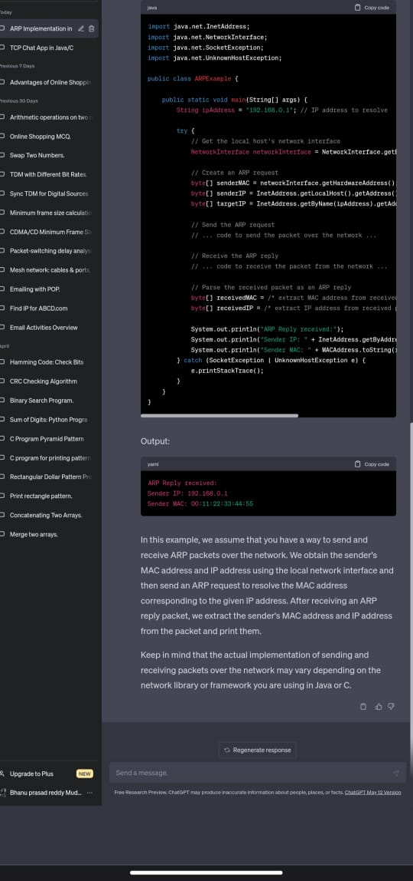

Exp No:32.Implementation of Bit stubbing mechanism using C

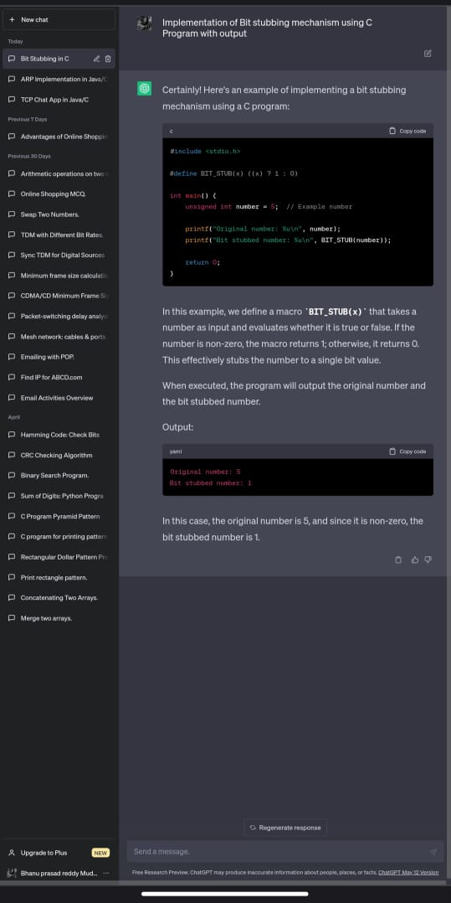

Exp No:33. Implementing the applications using TCP bile transfer in java/C

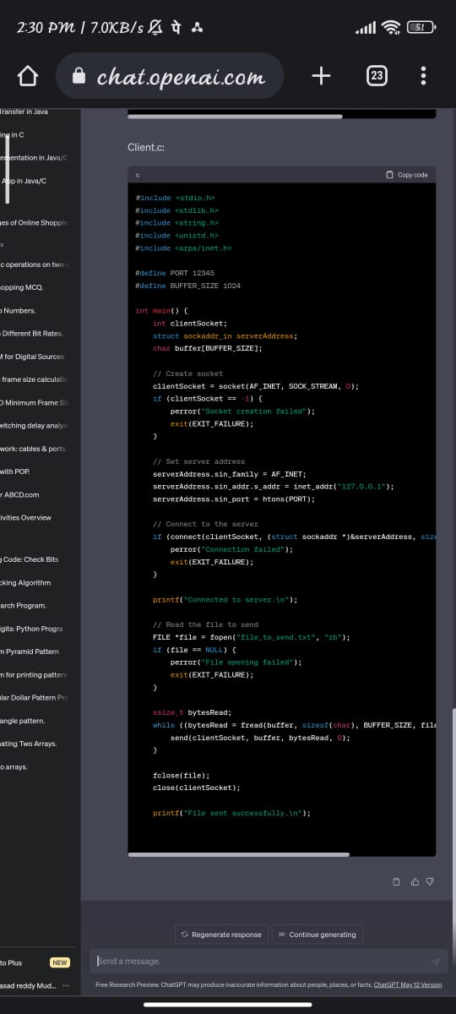

Exp No:34. Implementing the simulation of error correction code - CRC in java/C

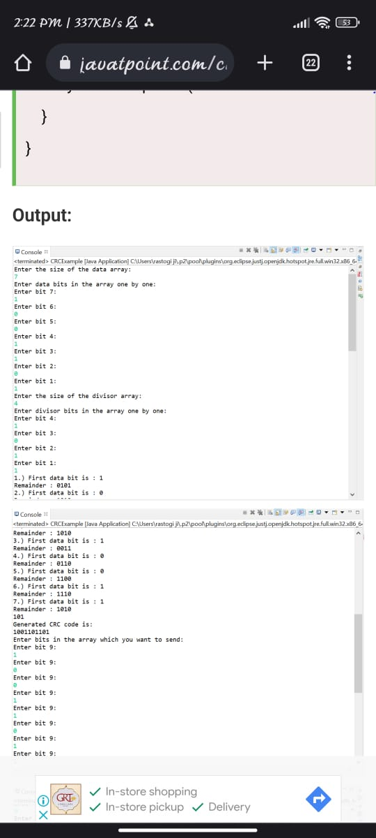

Exp No:35. Implementing the sliding window protocol in java/C.

